[TEAM 11]
sprint one
user manual
group exercise 1 part 4: prototyping in an initial sprint

[Proposed by]
Chai Song Lin, 2109920G
Ong Ming Thye, Derrick, 2110010O
Loon Ngai Fong, 2110002L
Pang Biao Yuan, Kevin, 2110012P
Pang Keng Hian, Reuben, 2110013P

Table of contents

Content Listing
Page Number | Content
1  2 | Cover Page  Table of Contents
3 | Brief Description - Program
4 | User Manual - Download
5 – 6 | User Manual – How to Run
7 – 18 | User Manual - Administrator
19 - 27 | User Manual - Tutor
28 | User Manual – Exit Program

brief description

program

This is a command line program, where Teaching Administrators should be able to export the selected course data as a CSV file, and upload this data to other University information systems. And Tutors should be able to record attendance of students at a particular session, and this data will be stored for university records.

Teaching Administrators are also able to edit, delete, import, and manually insert the grades into the system. They are also allowed to view either all courses' grades or single course's grades.

Other than the functions stated above for Tutors, they are also able to import, edit, delete, export, view, and manually mark the students' attendance.

user manual

Download

In order to download all java files needed to run this program in a zipped folder, click on the following URL and select the button that is highlighted in Figure 1.

http://bit.ly/188aimF

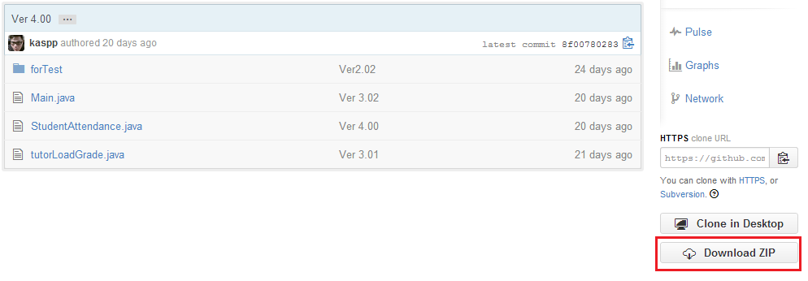
Figure 1: Download

user manual

how to run

Before you can run this program, the following three java files are required:
- Main.java
- StudentAttendance.java
- tutorLoadGrade.java

Firstly, using command prompt, navigate to the directory where all the java files stated above are stored.

To confirm whether the required files are inside the directory that you are currently working at, run the command "dir", to list all files in your current working directory like as shown in Figure 2.

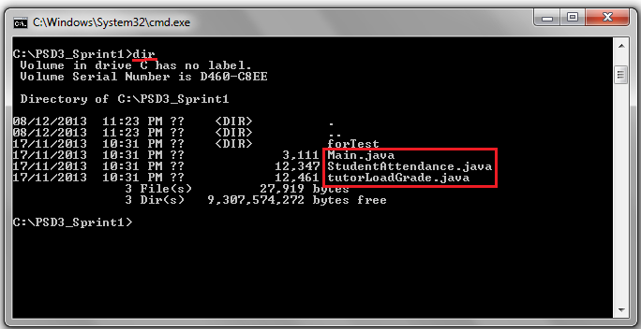
Figure 2: File Listing
user manual

how to run

Next to compile and run these java files using the command prompt, use the following commands:
javac *.java
java Main

As seen in Figure 3, upon successful compilation, the command prompt will then prompt you to login to the system.

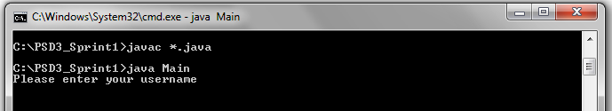
Figure 3: Compile and Run

user manual

administrator

If you want to export various data such as course data and students’ grades as a CSV file, you will need to login as an administrator. After successful login, a list of options to perform different actions will be displayed on screen as shown in Figure 4.

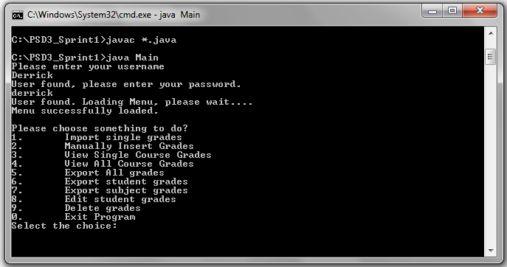
Figure 4: Admin Login

user manual

administrator – option 1

You can import in students’ grades by browsing to the CSV file using the GUI to select the desired file like as shown below in Figure 5.

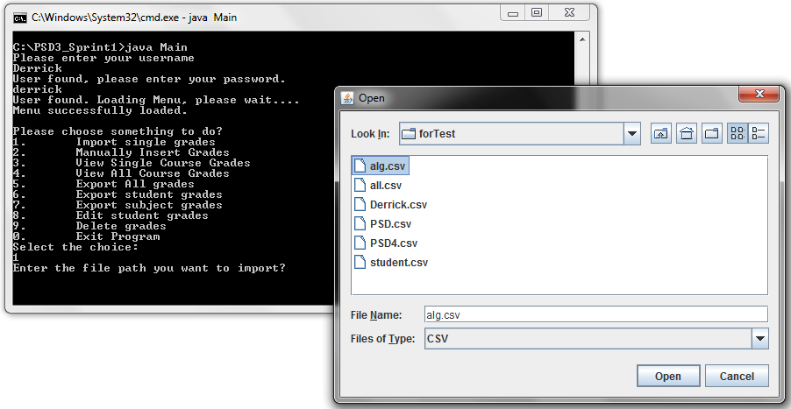
Figure 5: Option 1 - Import Single Grades

user manual

administrator – option 1

Next, you will key in the course name, and then the program will read the CSV file and search whether the specific student is found inside the database. If not found, the program will prompt you to add the student to the database.

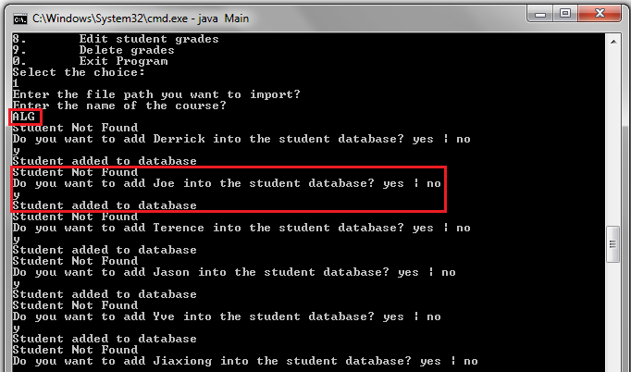
Figure 6: Option 1 – Adding of Students

user manual

administrator – option 2

If you want to manually insert each student’s grade for a specific course, select the second option from the list. As seen in Figure 7, you will then be prompted to key in details such as course name and grade for each individual student that is found in the database.

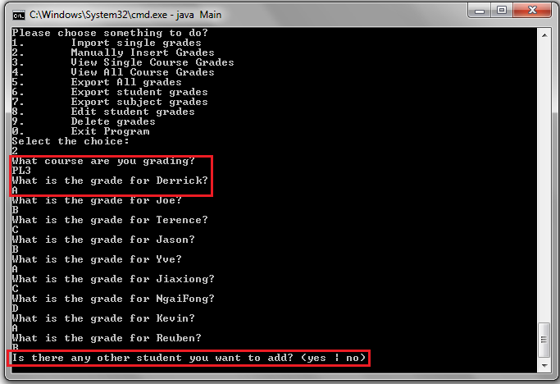
Figure 7: Option 2 – Manually Insert Grades

user manual

administrator – option 2

Additional students that are not found in the database can also be added after the manual inserting of grades for each individual current student found in database. The process will be ended when user has no more data to be inserted and the data keyed in earlier will be displayed out on screen like Figure 8.

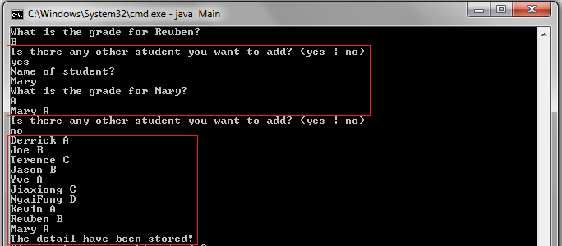
Figure 8: Option 2 – Insert Additional Student(s)

user manual

administrator – option 3& 4

By selecting option 3 or option 4 from the list, you will be able to view all students’ grades either by individual course or all courses together. If option 3 is chosen, you will then be prompted to key in the specific course name that you want to view and students’ grades will be shown.

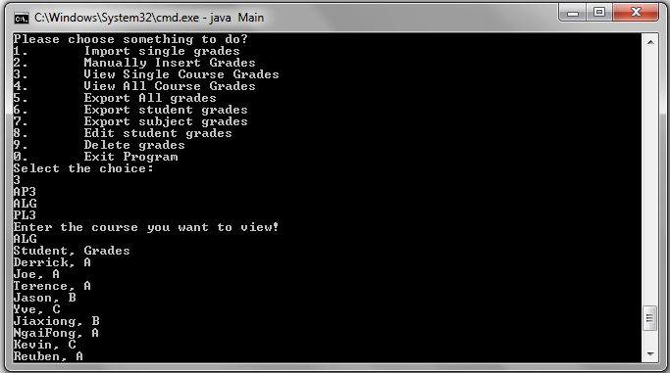
Figure 9: Option 3 – View Single Course Grades

user manual

administrator – option 3& 4

If option 4 is chosen, all students’ grades for all courses available will be shown together like in Figure 10 below.

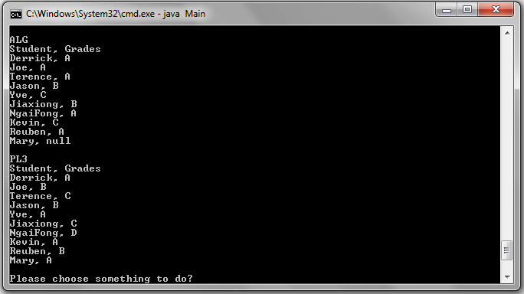
Figure 10: Option 4 – View All Course Grades

user manual

administrator – option 5-7

In this program, there are three different ways you can export the data. You can export all grades together in one CSV file (Figure 11), or export grades by each individual student (Figure 12), or export grades by individual courses (Figure 13).

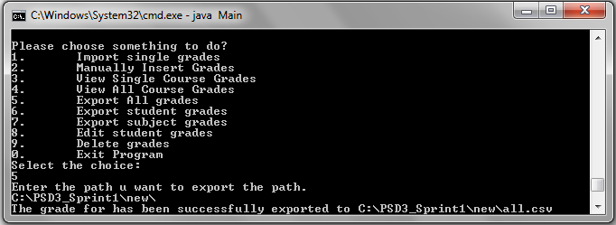
Figure 11: Option 5 – Export All Grades

user manual

administrator – option 5-7

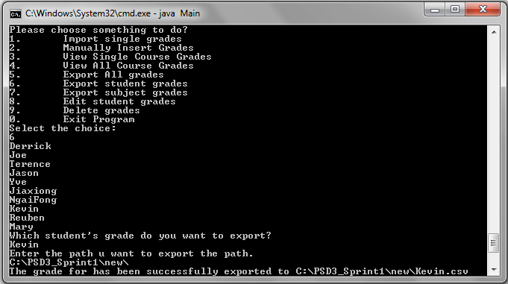
Figure 12: Option 6 – Export Student Grades

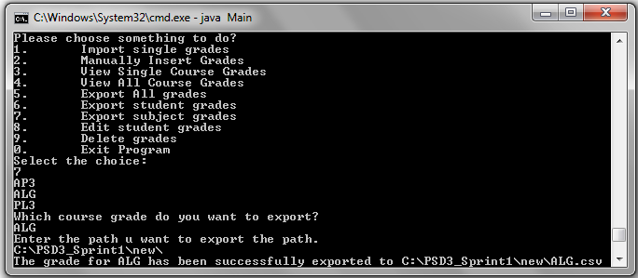
Figure 13: Option 7 – Export Subject Grades
user manual

administrator – option 5-7

The CSV files will be exported to the file path that is keyed in earlier by the user when prompted. Example in this case, all CSV files are exported to the file path:

“C:\PSD3_Sprint1\new\”

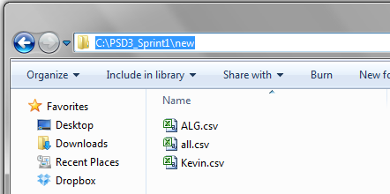
Figure 14: Option 5 to 7 – Exported CSV Files

user manual

administrator – option 8

If you wish to edit any student’s grade, you can choose option 8 from the list and change the grade of the student for a specific course, as seen below in Figure 15

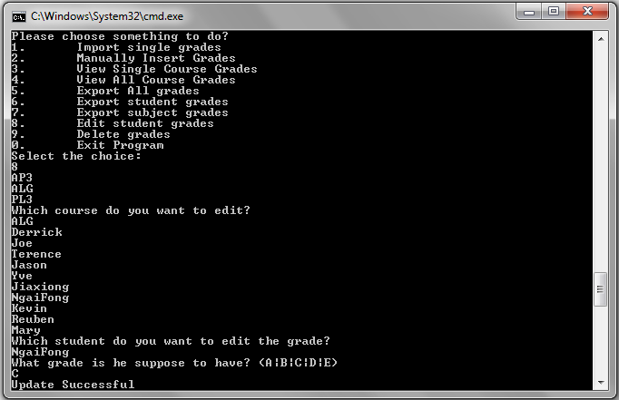
Figure 14: Option 8 – Edit Student Grades

user manual

administrator – option 9

Alternatively, if you wish to delete a course’s grades, you can choose option 9 from the list. Upon selection, the command prompt will ask which course you want to delete, like as seen in Figure 15.

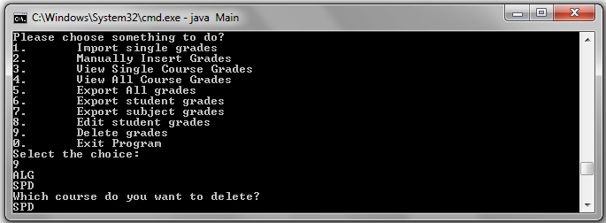
Figure 15: Option 9 – Delete Grades

user manual

tutor

If you want to record attendance of students at a particular session, so that this data can be stored for future university records as a CSV file, you will need to login as a Tutor. After successful login, a list of options to perform different actions will be displayed on screen as shown in Figure 16.

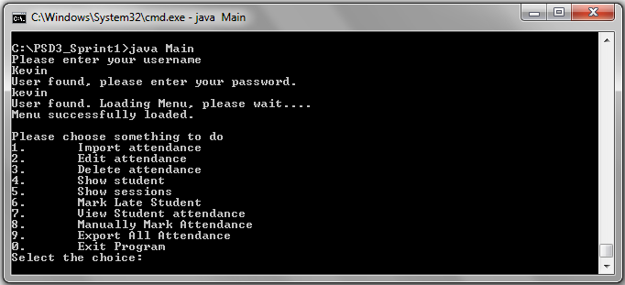
Figure 16: Tutor Login

user manual

tutor – option 1

You can import in students’ attendance by browsing to the CSV file using the GUI to select the desired file like as shown below in Figure 17.

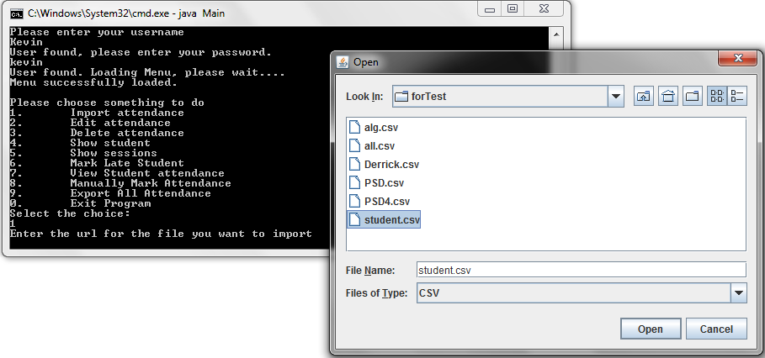
Figure 17: Option 1 - Import Attendance

user manual

tutor – option 1

After selecting the desired file to import, the program will then read through the file and search if this specific student is inside their database and prompt to add new student if not found inside the database like as seen in Figure 18.

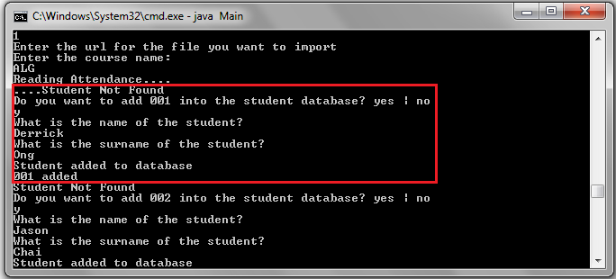
Figure 18: Option 1 – Adding of New Students

user manual

tutor – option 2 & 6

If a student is late for the session, or either you need to make some changes to the attendance, you can choose option 2 (Figure 19) or option 6 (Figure 20) to edit attendance or mark late attendance respectively.

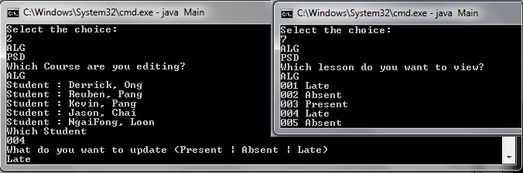
Figure 19: Option 2 – Edit Attendance

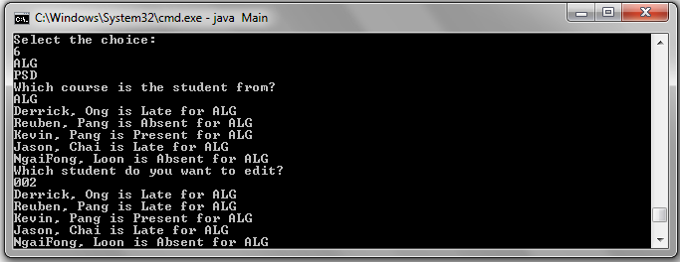
Figure 20: Option 6 – Mark Late Student

user manual

tutor – option 3

In order reimport or manually mark attendance again, you will need to delete the session’s attendance first by choosing option 3 from the list of options. Upon successful input, the session’s attendance will be deleted like as seen in Figure 21.

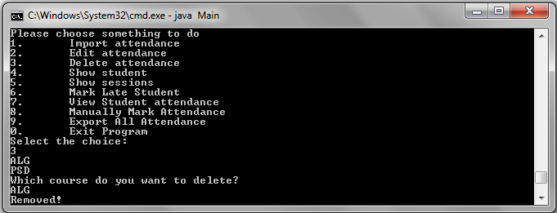
Figure 21: Option 3 – Delete Attendance

user manual

tutor – option 4 & 5

By selecting option 4 or option 5 from the list, you will be able to view all students’ names or all courses’ names together.

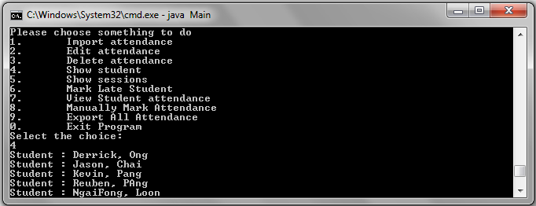
Figure 22: Option 4 – Show Student

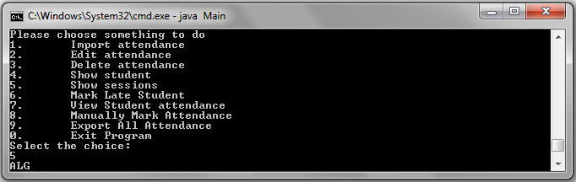
Figure 23: Option 5 – Show Session

user manual

tutor – option 7

By selecting option 7 from the list, you will be able to view all students’ attendance for a particular lesson as seen below in Figure 24.

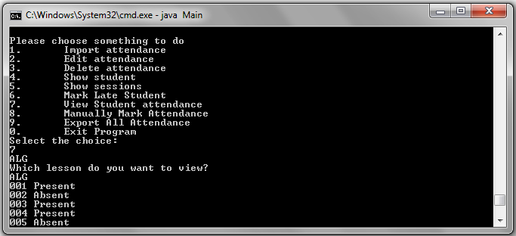
Figure 24: Option 7 – View Student Attendance

user manual

tutor – option 8

If you do not have any CSV file for importing of attendance and wish to manually mark attendance for the lesson, you can select option 8. This allows you to manually mark attendance (eg present/absent/late) for each individual student that is found in the database.

user manual

tutor – option 9

By choosing option 9 from the list of options, you will be able to export the attendance into a CSV file like as shown in Figure 26.

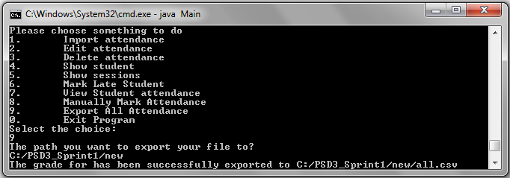
Figure 25: Option 9 – Export All Attendance

user manual

tutor – option 9

The CSV files will be exported to the file path that is keyed in earlier by the user when prompted. Example in this case, all CSV files are exported to the file path:

“C:/PSD3_Sprint1/new”

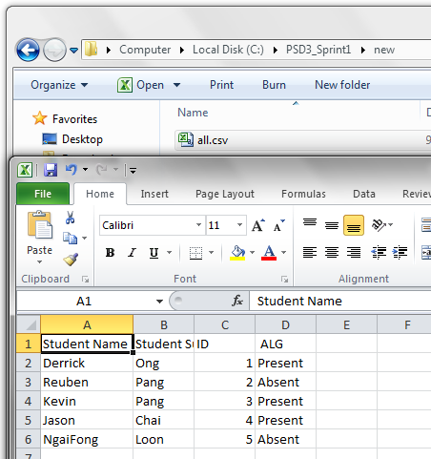
Figure 26: Option 9 – Exported CSV File
user manual

exit program

In order to end this program, you can select option 0 for both Administrator Login and Tutor Login. Upon successful termination of program, a message writing “Exit Success.” will be show.

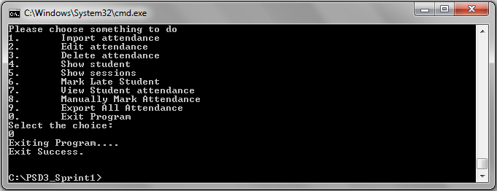
Figure 27: Option 0 – Exit Program

